Requirement elicitation

Interview record

Interviewer: Ronaldinho Nkoma, Computer engineering student

Interviewee (Client) MR Temba Moeba, Lecturer

Date: September 17, 2024

Purpose: To clarify the initial project brief and elicit detailed functional requirements for the new Banking System.

Interview Transcript :

Interviewer: "Thank you for your time, Mr. THEMBA MOENG. The brief mentions three account types. For the Cheque Account, could you clarify what 'working' means? Does a student with a part-time job qualify?"

Mr. TM: "Good question. For our purposes, 'working' means the customer must be employed and receive a regular salary. A student with a part-time job would qualify, but we must capture their employer's details for our records. The system must prevent us from opening this account type if these details are missing."

Interviewer: "Understood. Regarding the Investment Account, the brief states it requires BWP 500.00 to open. Should the system prevent its creation if the initial deposit is less than that?"

Mr. TM: "Absolutely. It's a hard rule. The transaction should be rejected, and the account should not be created. The same goes for any withdrawal that would bring the balance below zero. We don't offer overdrafts on investment products."

Interviewer: "What about the Savings Account? The brief says 'does not allow any withdrawals.' Is this a permanent lock? What if the customer wants to close the account to get their money?"

Mr. TM: "Another excellent point. 'No withdrawals' refers to partial withdrawals. The entire point is to lock the funds to encourage saving. The only way to get the money out is to formally close the entire account, which would involve a bank officer authorizing a final withdrawal of the entire balance plus any accrued interest. The system should allow this closure process."

Interviewer: "Noted. The system needs to calculate interest monthly. How should this be triggered? Is it an automatic process run on the last day of the month?"

Mr. TM: "Yes, it should be an automated background process. For this initial version, we can assume a bank administrator will press a 'Calculate Monthly Interest' button. This action should apply the correct interest to every eligible account in the system in one go."

Interviewer: "Finally, what information is absolutely critical for a new customer?"

Mr. TM: "We need to be able to identify and contact them. The minimum is: First Name, Surname, National ID Number, and Physical Address. A phone number is highly preferred but not mandatory for system creation. The National ID must be unique in the system."

Interviewer : “What do you think should be the appropriate response time of the system ?”

Mr TM : “The appropriate response time of the system should range from 3 milliseconds.”

Interviewer : “what are any other key features do you think the system should do that i may have overlooked?”

Mr TM : “The system should be able to display a list of the customers and their account types , so as to update information of the customers in the system by the bank . The system should also be design to keep up with the design trends of todays generation and interact with the user without any miscommunications.”

Interviewer : "Thank you, Mr. Themba Moeng. This has been very clarifying."

Mr. TM:"You're welcome. Please ensure the system is built with these rules firmly in place."

Structural modelling

Use case diagram

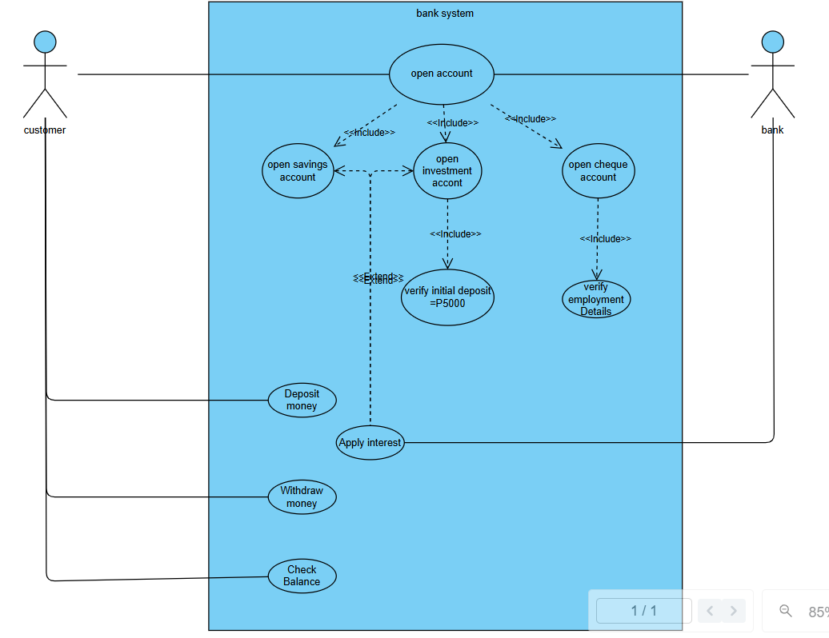

Class diagram

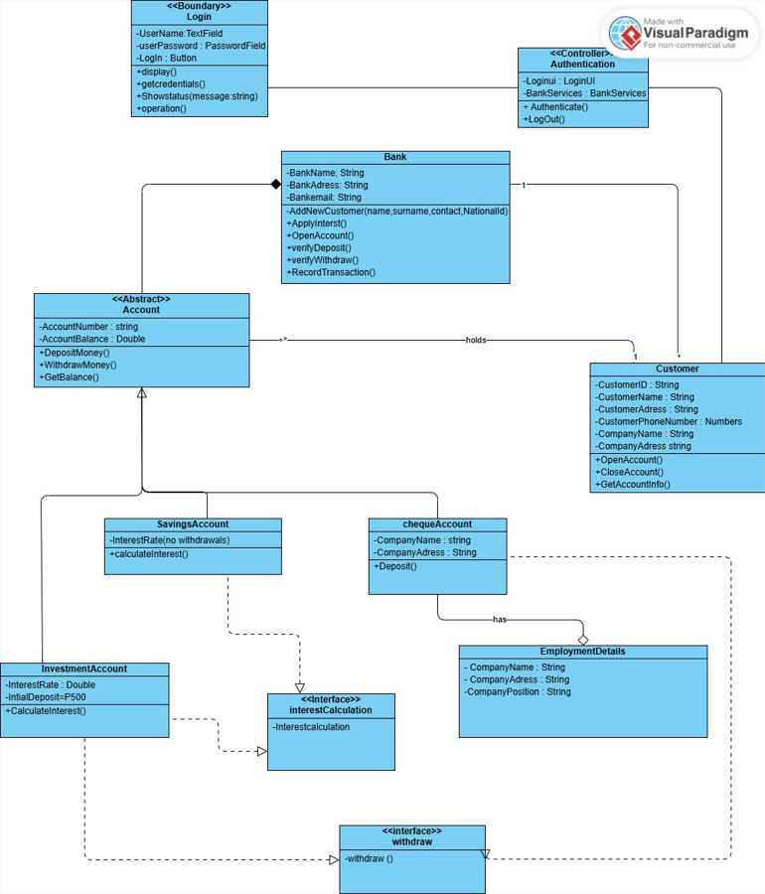

Behavioural Diagrams

Sequence diagram

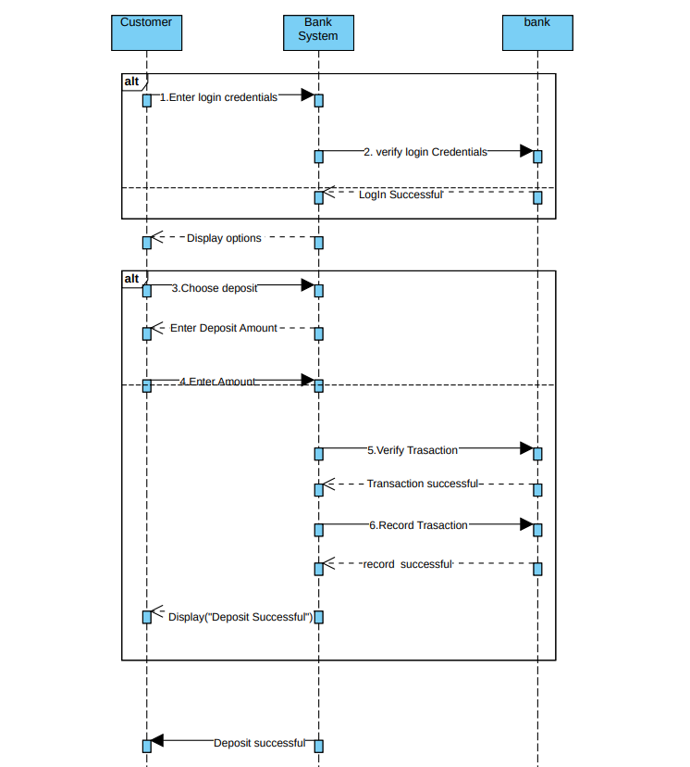

State diagram